Getting Started with the LERTAP 5 Prototype
• 20 June 2000 •
Larry Nelson
Curtin University of Technology
Perth, Western Australia

Extolation
LERTAP, the Laboratory of Education Test Analysis Program, is a classical item and test analysis software system which is used to process results from tests and surveys. Do you need it? Of course you do. Everyone should have at least one copy; most users have obtained extra copies for their kids and grandparents. It makes an ideal birthday gift, especially when bundled with a new computer.

Not convinced? Like to have a bit of sales pressure applied? We at Lertap headquarters have prepared some fancy brochures and flyers. See them at this Web site:

http://www.lertap.com

The purpose of the present document is to get you started using your new copies of Lertap. Congratulations on your purchase.

What’s Needed to Run It
Lertap 5 is written as an application for use with Excel. Excel is a spreadsheet program which works within Microsoft Office. It’s a standard component of Office, a suite of applications which also includes Word, Outlook, PowerPoint, and Access.

If your computer can run Office, chances are good it can run Lertap. At Lertap HQ we presently use Office 2000, and currently operate within Windows 98. A common question is: Will Lertap work with Office 97? The answer is Yes, a few sites are running it under Excel 97; some problems were reported at first, but these seem to have now been ironed out. Will it work on a Macintosh computer? If it’s running Office 98, Yes, it seems to, but only one site has tested it so far.

Is Excel all I need in order to run Lertap? Well, no. You must have a copy of the Lertap 5 Excel workbook too. An Excel “workbook” is simply a file, one which will usually have an extension of xls, xlt, or xla. Workbooks are to Excel what documents are to Word.

To find out how to get a copy of the Lertap 5 workbook, please refer to the Web site. Come to think of it, you must already have a copy. Why else would you be reading this? The fish aren’t biting?

What It Looks Like
Okay, there you are, you’ve got Excel on your computer, and you’ve also got a copy of the Lertap 5 workbook on the same computer. You remember where you put the Lertap 5 workbook, that is, the spot, or “folder”, on your computer’s hard disk. Got a favourite hot beverage to sustain you? Great.

Ready, set, Gentlemenandwomen, Start your Lertaps!

There are a couple of ways you can do this. I would go to the folder where I parked the Lertap 5 workbook, and double-click on the icon for the workbook. Another way to crank up is to start Excel, and then use Excel’s File menu to Open the workbook.

You know you’ve been successful when you see a screen which bears a reasonable resemblance to the following:
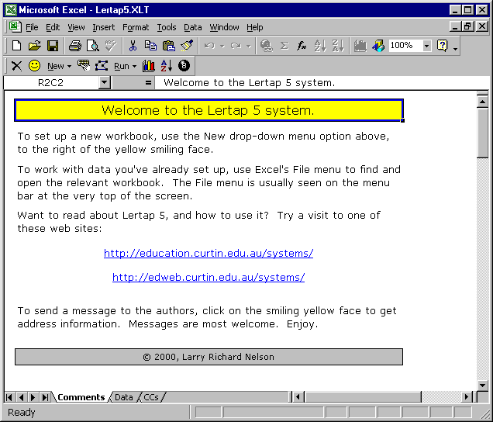

Got your hot cuppa ready? Take a tug on it. I need to introduce you to various parts of the screen above, just to get down some important terms. This is where I can lose the audience, but it’s got to be done—if, later on, you come across a term which you don’t recognise, it could well be due to inattention here, at this crucial spot. So, top up your cup, if needed, put on some of your favourite music, and Listen up!

Let’s divide the screen into three areas, and think of meat in a sandwich. The meat is the centre section, starting where the Welcome to the Lertap 5 system banner is, working down to the smaller ©2000 Larry Richard Nelson banner. The meat, in this case, is a window which is displaying part of a worksheet. The name of the worksheet is “Comments”. More about the name soon.

The top layer of bread could be said to have five sublayers. Closest to the meat is the formula bar. The R2C2 says that we’re looking at a particular cell in the worksheet, the one which is at the intersection of Row 2 and Column 2.

Above the formula bar there’s the Lertap 5 toolbar. This is the line with the smiley face on it, and the eight ball. The Lertap toolbar which you see may differ a bit from that shown above.

Above the Lertap toolbar is one of Excel’s main toolbars. In this case it’s the standard toolbar (it’s actually called that by Excel). This is the line which has the box with 100% on it.

Above Excel’s standard toolbar is what I call the Excel menu bar. This is the line with File Edit View and so on. On top of that, the epidermis of the top slice of bread, is the name of the main application, Microsoft Excel, followed by the name of the Excel workbook which is on show.

Good on you. Still with me. Have some more coffee or tea or hot chocolate or whatever. These terms are important.

Let’s come now to the bottom slice of bread, immediately below the meat.

The first line has two fundamental areas. I find this line to be a bit tricky to work with at first. Actually, it’s dead easy to work with, once you come to terms with it. What is difficult is trying to explain, on paper, what it does. (Send us a business-class air ticket, and a multi-lingual Lertap representative will come to your house to give a live demo. Have a couple of beers and some peanuts ready, if you please.)

The left-most area on this line has four arrow heads, followed (Listen up here!, this is really important) by three small tabs, much like the tabs you might see on the manila folders in your file drawers (oh that my file drawer tabs could look so neat; I wouldn’t even mind too much if the tabs were on the bottom of the folders, as they are above).

The tabs are named: “Comments”, “Data”, and “CCs”.

Each of these tabs corresponds to a separate worksheet. What’s a worksheet? You’ll see later. The Comments worksheet looks more like a page in a word processor than the grid typical of spreadsheets—when we get to see the Data worksheet you may better appreciate the use of the term worksheet.

Now, the present workbook, Lertap5.xlt (this is the name which is seen on the epidermis, top slice of bread), has just three worksheets in it at the moment. But when Lertap gets to strutting its stuff, it adds more worksheets, and that’s when the four little arrows at the left stand up and say Use us, we let you scroll among the worksheets, just Click us!, please. Really creative Lertap users will sometimes have a workbook with dozens of worksheets, and this is when that small family of arrows finds its real meaning in life.

Okay, there you are still. Of all the things on display above, it’s those tabs and four arrows which are generally quite novel, and sometimes difficult to explain.

To the right of the tabs, beyond the empty space reserved for more tabs, there’s a standard horizontal scroll bar, which at the moment is stationed at its left-most. This bar is used to scroll from the left side of the meat to the right side. I happen to know that there’s nothing worth viewing to the right on this worksheet; try it for yourself.

The very bottom of the bottom slice of bread shows the status bar, which is, at the moment, happy just to say Ready. As you use Lertap, and Excel, messages appear in this area.

So, is that it? No. You forgot to ask about the scroll bar appended to the right side of the meat. This is a vertical scroller which lets you see how thick the meat is. Many Lertap worksheets get to be quite thick.

Go for it—you deserve another hot top up in that mug. Why not a sandwich?

The Data Worksheet
The Lertap 5 system requires two core worksheets before it will do anything for you. One of them has the data to be analysed; the other contains lines which you use to control Lertap’s operation.

Take a look at the Data sheet below:

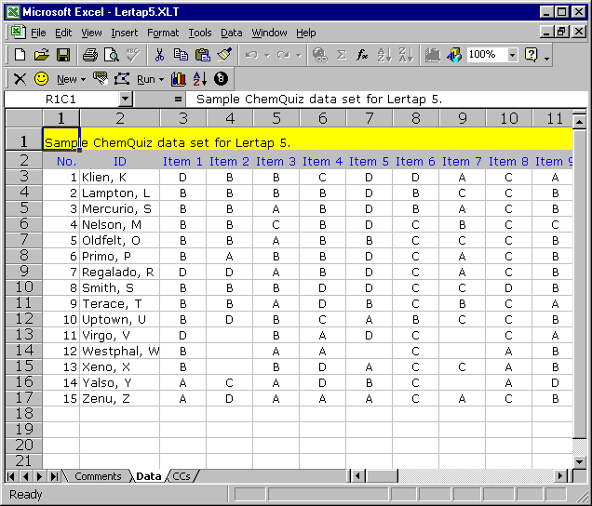

Doesn’t this look more like a dinkum worksheet? Sure does. Why, it’s got distinct rows and columns which are pretty easy to see, and there are now numbers down the left side to show which row we’re on, and more numbers at the top of the meat to indicate which column we’re on. Right now the formula bar says we’re meating at Row 1, Column 1.

How come this worksheet has row and column numbers; they’re aren’t any on the Comments worksheet? Because I wanted them here, and not there. I reckon worksheets sometimes look a bit smarter without the row & column “headers”, as Excel calls them, and so I occasionally turn them off.

You too can enjoy such power. If you take your little mouse and drift up to Excel’s menu bar, and click on Tools, and then on Options, a new world will sparkle before you, behold:

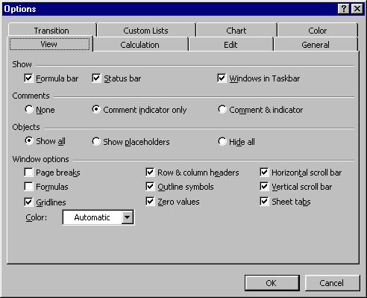

Look at all those boxes to check / uncheck, Gol-leee!, as Grandma Lula used to say. What’s all this about? Mouse up to the upper right of this Options screen, click on the small question mark, ?, and then click on a box you’d like explained.

I say Larry, I’ve used spreadsheets before, and aren’t columns often denoted with upper case letters—with the first column being A, the second B, and so forth? Yes, you’re right. Good question. Good point. Lertap much prefers to have both rows and columns numbered, and Excel allows for this via what it calls its R1C1 reference style. You can change the referencing style by clicking on the General tab in the Options screen—do you see this tab above?

Okay, back to work. Back to the actual Data worksheet. It displays the answers which 15 students gave to a 10-item multiple-choice test on the periodic table.

The top two rows of the worksheet have headers, or titles. The first column in the actual data area has a sequential number for each student. The second column has the student’s name, or “ID”. Subsequent columns contain each student’s response to each item. On Item 1, for example, K Klien took option D, an option selected by just two compatriots, Regalado and Virgo.

Some of the cells in the worksheet are empty. Item 2, for example, has empty cells for Virgo, Westphal, and Xeno. These three students did not answer the question.

Is the Data sheet pretty self-explanatory? Common questions I get concern the colouring seen in the sheet, which you might not be able to see if you’re reading this in black and white. The first row has a yellow background, the second row a grey background, and the column titles seen in the second row are all in blue.

The colours are simply cosmetic. They’re easy to activate—another Excel toolbar, called the formatting toolbar, has the colour options. How to get this toolbar to show? A couple of ways—if you’re using a Windows computer, right-click on the standard toolbar, or use the View menu’s Toolbar option.

The colours are not important. They are not required. What is important is that the Data sheet have two rows for header information, followed by the item response data. There is more on the Data worksheet later.

Note for SPSS users: it is fairly easy to export a Lertap worksheet so that SPSS will read it—the eight ball icon on the toolbar is made just for such work. If the Data worksheet is later exported to SPSS, the column headers in the second row of the Data worksheet are passed to SPSS as variable names. SPSS has some restrictions on variable names, and these are best kept in mind: the names cannot be longer than 8 characters, and may not contain blanks (or spaces). They must begin with a letter. They should not end with a period (full stop), but periods may be embedded in the name; for example, My.Itm01 would be a valid SPSS name. The underscore may also be used, as in My_Itm01. With these comments in mind, the headers on the item columns above, Item 1, Item 2, and so on, would be unacceptable to SPSS as they contain a space—SPSS will replace these headers with generic variable names, and continue to run.

The CCs Worksheet
Your comportment is exemplary. See if you can hang on for one more screen shot before you take a break. Look:

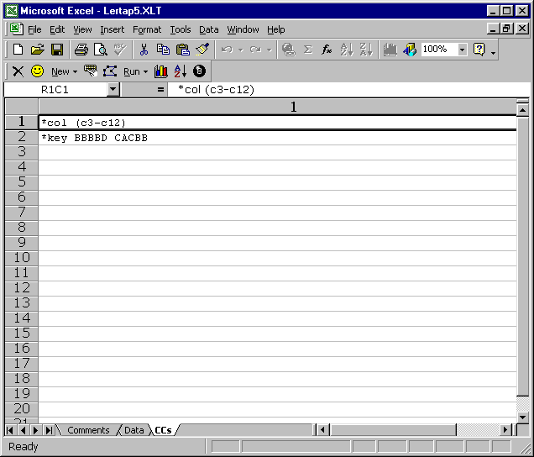

What have we here? Looks like a pretty simple worksheet with a strange name. CCs? Stands for control cards. When Lertap first emerged, back when Gondwanaland was still intact, I am told they didn’t have personal computers, and colour screens, and keyboards. They had something called “punch cards” which they prepared on a “keypunch machine”. (Did they have beer?)

Some words have a habit of sticking around. Lertap 5 wants you to regard the two control lines seen above as “control cards”. Just humour it along, as your kids do you when you talk about steam trains, unsliced bread, home milk delivery, wood burning stoves, and taking walks in the city after dark.

The first little control card above tells Lertap that item responses are found in columns 3 through 12 of the Data worksheet. The second control card has the keyed-correct answers for the 10 items.

And there you have it: a brief, concise introduction to how Lertap 5 looks when you wind it up. In order to apply Lertap 5, it will be your job to set up your own Data and CCs worksheets. The example shown here is short, true, but it’s right on target in showing how you get started. In fact, the example is complete, there’s nothing missing—if I went to the Lertap toolbar, and clicked the Run menu, I’d be off straight away—Lertap would give me results, including test scores, and item and test performance data (usually called statistics, but I don’t want to frighten you off).

You deserve a break. Me too. Take one, and then we’ll talk about having you get started with your own data.

Setting Up Your Own
The most important thing you need to have on hand before starting up is some test results. Got ‘em? Got Lertap 5 running on your computer? Got a fresh cup of coffee (maybe it should be decaffeinated as you may be drinking a lot of it during this session)?

Okay, good. Mouse up to the Lertap toolbar and click on New, would you?

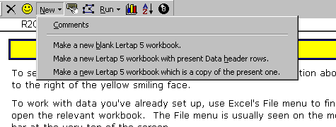

Hopefully you are looking at something like the above screen shot, and hopefully what you see is less blurred than what’s come out here.

There are four lines showing above, starting with Comments. If you click on Comments you’ll get a brief overview of what you’re about to read below.

If you click on Make a new blank Lertap 5 workbook, Lertap will get Excel to open a new workbook for you, and it will have two blank worksheets in it, one called Data, the other CCs.

If you click on Make a new Lertap 5 workbook with present Data header rows, Lertap gets Excel to create a new workbook with two worksheets, one called Data, the other called CCs. The CCs worksheet will be a copy of the CCs sheet in use when you clicked on New, but the Data sheet will have only its first two rows filled in. Filled in with what? With a copy of whatever is found in the top two rows of the Data worksheet which was in use when you went to click on New. This is the option I most recommend. The two rows we’re talking about may not be exactly what you need, but they provide a sort of template which you can modify. The same can be said of the CCs lines—in some cases they will be exactly what you want, but in many cases you’ll want to step in and change them.

If you click on Make a new Lertap 5 workbook which is a copy of the present one, Lertap gets Excel to create a new workbook with two worksheets, one called Data, the other called CCs, and these will be complete copies of the Data and CCs worksheets which were in use when you went to click on New. Note that this line is a bit misleading in that it implies you’re going to get a complete copy of the present workbook, which is not true if the workbook has more than two worksheets—Lertap is programmed to copy only the Data and CCs sheets. Larry, what if I want a complete copy of my workbook? I’ve used the Run menu, and Lertap has given me other sheets which I’d like to copy? If you had a Word document which you wanted copied, what would you do? I would go outside of the application, be it Excel or Word, find the folder containing my file, and copy it from there.

Now I scratch my head. Where to take you next? Some of you will be tyros, some will be experienced Office and test users. I think the best option is for me to take the second option, Make a new Lertap 5 workbook with present Data header rows. I have my test data on hand, a 63-item multiple choice test from a postgraduate ed psych unit with 60 students. I click on the second option (which is the 3rd line if we count Comments), and here’s what I see:

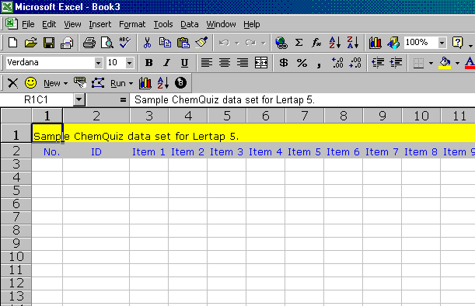

Excel, acting as Lertap’s accomplice, has opened a new workbook with two worksheets in it, Data and CCs (you can’t tell this from the screen shot above; trust me). What’s the name of this new workbook? Don’t know if you can make it out above, it’s in the epidermis layer, the very top of the screen. It’s named it Book3. Why does it have such a funny name, can I change it? This is just standard procedure—if you’re in Word, and create a new document, doesn’t it get called Document1, or 2, or 3, or something? Yes. Can you change the name? Of course! Gee, what are you, dumb? (I can talk like this as we’re in a postgraduate class, and postgrads should know how to save files. In undergraduate classes I am more respectful of beginners.) To save the new workbook with a nice name, use Excel’s File menu.

Let’s see, back to work. I have to change the title, the first row of the Data sheet. I click at the junction of Row 1, Column 1, where “Sample ChemQuiz data set for Lertap 5.” is presently displayed. I type in a new title, seen below:

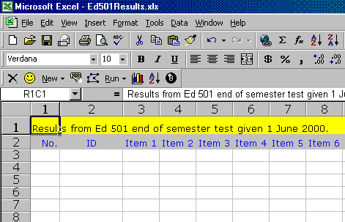

See the new title in Row 1? Can you also make out that I have saved this new workbook, using a name of Ed501Results? (The workbook name shows at the very top of the screen, with a dark-blue background which looks nice on screen, but often copies poorly to print.)

Okay then, I am set to enter actual test data. Before staring that, let’s review how I got here. (Says Mom: Why, one wonderful day in August Grandma brought you with her on the 3 o’clock train from Chicago.)

I arrived at this spot for a very explicit reason: I had administered a multiple-choice test in one of my classes, and wanted to process results on the computer. Accordingly, I started up Lertap 5. I noted that Lertap came up with its sample of ChemQuiz results. Hint, Listen up!: after you’ve Lertapped for a while, you’ll know that you can often save a bit of work by at this point opening, for example, the workbook with last semester’s Ed 501 results—if you’ve given the test before, then the first two rows in the Data file, and probably all the rows in the CCs file, can be copied, yesiree.

I went to Lertap’s New menu, and took the option which said it would Make a new Lertap 5 workbook with present Data header rows. Sure enough, I immediately got a new workbook, called “Book3” in this case, with two worksheets, Data and CCs. The Data worksheet came with its first two rows filled in. Neither of these rows had exactly what I wanted in them, so I started by changing the title in the first row to something which described the present job. Behind the scenes I did something else: while you went to powder your nose or get rid of some of the coffee which had worked its way through, I saved the new workbook with a new name.

Entering Data
My next step is to fill out the Data worksheet with my actual test results. The test I gave students had 63 items, but my test questions did not follow a standard numbering sequence. I started with Items 1 through 36, but then had Items 37a, 37b, 38a, 38b,39a, and 39b, after which sanity returned, and I closed out with numbers 40 through 60. So, one of the first things I have to do is get into the second row of the Data worksheet, and change some of the column headings. Here’s a partial snapshot:
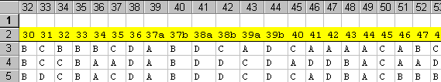

My item numbers are in the second row of the worksheet, and here you can see that I had already typed in some student answers from row 3 down. What are the numbers which show at the very top of this screen shot? They are Excel’s column numbers for the worksheet. Please look: responses to Item 34 appear in worksheet column 36; responses to Item 39b are found in column 44; while responses to Item 46 are in column 51.

So, what have I done so far? I put a new title in row 1 of the Data worksheet, and I changed the item numbers to reflect my needs. Am I ready to enter results?

Are the first two columns, those headed “No.” and “ID”, suitable for my test results? Yes, these are the two identification fields which I commonly use.

When I get test results back, I stack them all up, throw them in the incinerator, and head for the beach. Western Australia has some spectacular beaches.

Just checking. How are you doing?

When I get test results back, I stack them all up, and then pencil a sequential number on each student’s return. Some colleagues use the University’s Student ID number instead.

In your own work, you can have any number of identification fields. Here I have two, No. and ID. There can be more, there can be fewer, there can be none. Hint, Listen up!: If one of the first two columns has a heading which begins with the letters ID, even with id, then Lertap will use it to label the test scores which it produces. Recently my good friend Piet Abik sent sample results from one of his senior high school science classes in Pontianak, and he had labelled the student name column Nama Siswa, which is common in Indonesia. I changed it to ID Nama Siswa so that Lertap would use the names found in this column in its Scores worksheet.

So, I guess I’m ready to type in results. It’s a straightforward process. I mouse to the first row for student data, and click in the first column. I pick up the first results sheet, and type in the pencilled number. I use the <Tab> key to move to the right, to the next column, where I type in the student’s name. Then I <Tab> to the next column, and type in the student’s answer to Item 1. Tab to the next column, type the next answer; tab, answer; tab, answer; … ; tab answer.

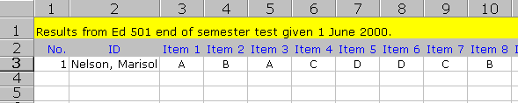

Ho hum, boring. Too bad I have to use that Tab key so much.

Ah, but you don’t. Let me introduce you to The Spreader.

Data Entry Using The Spreader
Take a look at this worksheet, would you?:

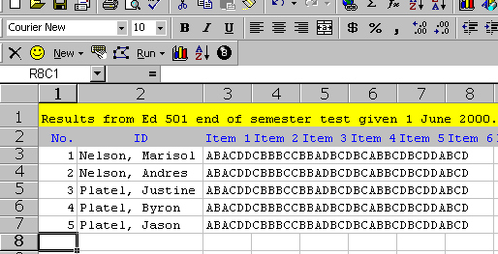

Something’s different here, very different (!). All student responses have been typed in one long string. No tabbing to adjacent columns? No, none. There’s nothing between those answers that we can’t see? No, nothing—student answers were typed in as one long string.

I know I can get away with this because of The Spreader. It’s a tool on the Lertap toolbar which will spread strung-together item responses to the right. Here’s what I would do to spread Miss Nelson’s results: I’d mouse to where her strung-together answers are and click. Then I’d mouse up to Lertap’s toolbar, and click on The Spreader, which is the strange looking icon immediately to the left of the Run menu. It looks like this:

And it results in this; look at Marisol’s results now:

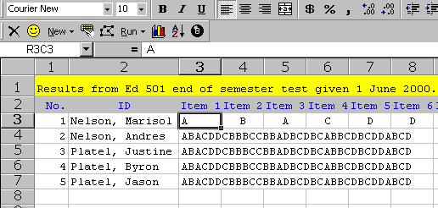

I would continue by moving down the third column, where the responses are strung together, and clicking repeatedly on The Spreader. However, before doing this, I would pause, and change the worksheet’s font to Courier New. You may have noticed that I already did this. How’d I do it? First of all, I went to Excel’s View menu, then Toolbars, and turned on the formatting toolbar. Then I selected all cells in the worksheet by holding down the CTRL key, and pressing the A key (this is a shortcut which I learned sometime ago; it’s the fastest way I know of to select all contents in an Excel sheet). Finally, I went up to the formatting toolbar, and changed the font to Courier New.

Terrific, Larry, thanks much. But why did you do this? It’s great having Len in the class as he asks such good questions. The answer is that Courier New is what’s called a fixed-pitch font; all its characters have the same width. Knowing this to be the case, I can then see if the string of strung together item responses is the same length for each student. If it’s not I will suspect that a response has been missed out, a data processing error.

This prompts AP to ask: What if a student does not answer an item? How do I enter a nil response? Non responses can be common. When I find them, I use the space bar on the keyboard to enter a blank, that is, a space. This will show up well in the string of strung-together responses if I use a fixed-pitch font, such as Courier New. Some people use a special character to indicate a non response, and many times they choose the digit 9 as this character. This digit, 9, has historically been used as a missing-data code in other software systems, such as, for example, SPSS.

Now Cheryl Hough has her hand up. She generally sits in the back row so as to work on crosswords, but today she forgot to bring The West Australian. She chirps up to provide a very worthy titbit. Look what she did:

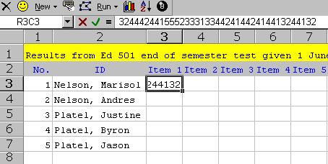

Cheryl had results where all item responses were digits instead of letters. She knew that this was fine by Lertap, and she also knew about The Spreader. So she started to type in Marisol’s results, and when she dropped down to enter the string of digits for Andres, look what Excel did:

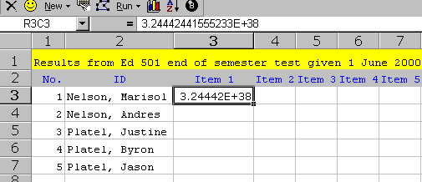

Excel thought Cheryl was working with numeric data, and converted the long string of digits, which it thought was a number, to scientific notation. If The Spreader is asked to spread to the right, it does so, but takes along the decimal point, the E, and the + sign. Yuk.

The way to control for this is to highlight the column where the strung-together response will live, and then use Excel’s Format menu to specify that the column contains “text”.

How to highlight a column? Click on its number. Then click on Format, Cells, and select “Text” from the Number tab, as shown here:

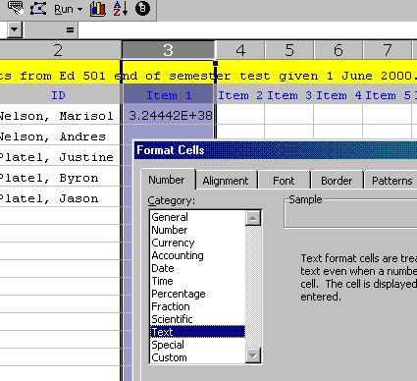

The Control Cards
I have been anxious to get to this section. It’s where Lertap shines. Of course, it shines all over, but the real magic, fun, and excitement comes when you deal with Lertap’s control cards.

After you’ve entered your test responses in the Data worksheet, you come to the CCs worksheet and type in a few lines, or, “cards”, which tell Lertap how to make use of all that stuff you put into the Data sheet.

If Lertap could talk (we’re working on that), it would say, Okay, Cesar, where have you put your item responses? Cesar, who knows how to speak Lertap, says *col (c3-c65). He says this by typing it into a line in the CCs worksheet.

You may need some coaching in this new language? You could travel to Lima to meet up with Cesar Merino, where he works as a school psychologist. Or, you could send us a business-class air ticket, and a smiling multi-lingual Lertap representative will come to your house to give a live demo. Don’t forget the beers and peanuts.

What has Cesar said to Lertap? Simple. He’s said that his item responses start in column 3 of the Data worksheet, and run through column 65.

Gracias, mi vida. Ahora dame las llaves del coche deportivo. Lertap says thanks, and asks for the keys to his sports car. Cesar recognises this as a cleverly-worded request for las claves, the keys to the items, and so he types the following into another line in the CCs worksheet:

*key CBBACABCDBADABDDBCCACBBAAACBCBCCBACDABDCCDDADBACABCBDBDBCDADDDA

With this line Cesar gives Lertap the right answer to each of the items on the test.

And that could be the extent of Cesar’s conversation with Lertap. He types these two lines into the CCs worksheet, hits the ice box for una cervezita, and then mouses up to Lertap’s Run menu to start the action (more about this below).

So, Larry, this is it? This is fun and excitement? Okay, I take the point. Lertap’s vocabulary is a bit more extensive; you can get worked up, you can talk up a storm in the CCs sheet if you want to. For example:

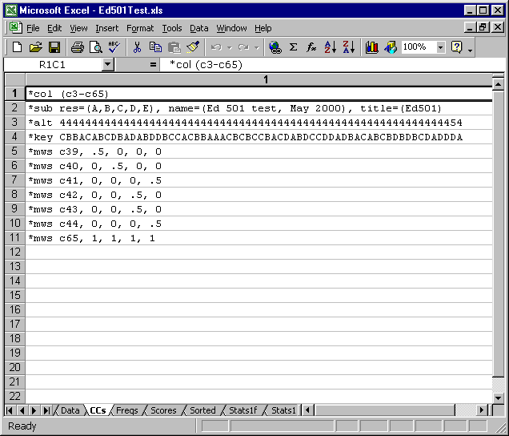

If this doesn’t tickle your fancy, how about this conversation between Bruce Shortland-Jones and Lertap:

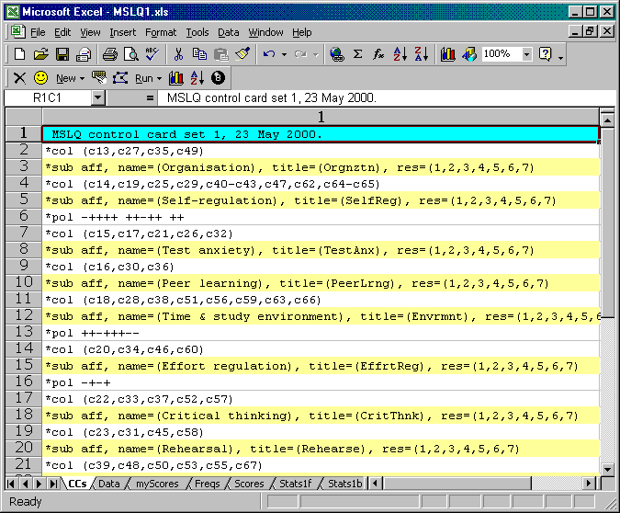

I’ve flashed no less than three sample CCs sheets at you now. The first one, back a few pages, had just two control cards, *col and *key. This was a straightforward job, and the person who set it up didn’t feel a need to converse more with Lertap. She could have, had she wanted to—for example she could have whispered “*sub …” to Lertap, and asked Lertap to use a special name and title for her results worksheets.

You can see a bit more of a dialog in the second CCs example, the one with 11 cards, beginning with *col (c3-c65). This was Rich Coatney, of Ohio State fame, setting up his class test. Rich talked *sub, *alt, and *mws with Lertap, with the *mws cards used to tell Lertap that the correct answer for six items, those whose responses were found in c39 through c44, was to get just half a point. He also had one item, found in column 65, where every single answer was to get a point.

I say, What’s Rich’s *alt card doing? See the res=(A,B,C,D,E) specification on the *sub card? It says that the items on the test could use as many as five responses each. In turn, the *alt card says that all but one of the items used just 4 of these five; there’s a 5 close to the end of the *alt card, but it’s the only one.

And what about the talk between Bruce and Lertap? Twenty-two control cards, and counting … what a conversation! Bruce was explaining to Lertap how to process results from his administration of the MSLQ, the Motivated Strategies for Learning Questionnaire from the National Center for Research to Improve Postsecondary Teaching and Learning, University of Michigan.

The MSLQ has several scales. Bruce used a *col card to tell Lertap about these scales. He used a *sub card to give a name and title to each scale, and he talked *pol to Lertap so that the scoring of some of the scale items would be reversed.

Ah, I knew it, I knew it, I just felt it coming. Everyone’s got their hand up. Can we have some extra sessions on talking Lertap, please, please? You asked for it, you got it. Hurry to your bookstore first, and, if they’re not sold out, get a copy of: An Introduction to LERTAP 5 Control Cards.

Getting Results
Some classes go so well you hate for them to end. But we’ve got a couple of minutes left; let me show you how easy it is to get Lertap to gin up some results.

Mouse up to the Run thing on Lertap’s toolbar, and click it.

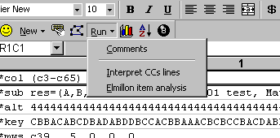

You’ll start your data analysis by asking Lertap if it’s understood what you said. All that talking you did in the CCs sheet—did Lertap comprehend? The answer to this will reveal itself once you click on the Interpret CCs lines option. Such clicking gets Lertap to listen very carefully, and, having done so, it will then tell you what it thinks your CCs words mean.

If the two of you agree on who said what to whom, a click on the Elmillon item analysis option will have Lertap rush off to read the data you put in the Data worksheet, making test scores according to the instructions you wrote about in the CCs worksheet. It will create a new worksheet called Scores, and then make two other worksheets called Stats1f and Stats1b, for “full” and “brief” statistics, respectively. If you had more than one *col card in the CCs worksheet, there will be other worksheets with full and brief statistics. Bliss, bliss, bliss.

Adjournalation
We have run out of time. Let’s adjourn for the day. Your assignment is to try entering your own data, and speaking Lertap by writing messages in a CCs worksheet. Try an easy job first, one which requires just a *col card, and a *key card. There’s a sample data set or two on the Web site.

Go to the bookstore to get An Introduction to LERTAP 5 Control Cards.

In tomorrow’s class we’ll have an introductory look at sample Scores, Stats1f, and Stats1b worksheets, and we’ll start to speak some more advanced Lertap by looking in depth at examples. Should we bring our swim suits? For sure. Don’t forget the beer and peanuts.

