Using LERTAP 5’s Run Menu.
• 20 June 2000 •
Larry Nelson
Curtin University of Technology
Perth, Western Australia

This document is not an introduction to using the Lertap 5 test and survey analysis system. It’s assumed you already have some familiarity with Lertap, and what it can do.

You may have worked through the document titled Getting Started with the Lertap 5 Prototype. You may also have seen some of the information posted at the Web site: http://education.curtin.edu.au/systems/

I will assume you have entered some data into a Data worksheet, and have also set up some control cards in Lertap’s CCs worksheet. You’re ready to get results, and keen to read about how Lertap does some of its processing. Okay? Ready set go.

The ChemQuiz Data Set
The ChemQuiz data set is one of the examples seated on the Web site. It’s a typical example of a classroom achievement test. In this case a class of 15 students in a junior high school chemistry class responded to a teacher-made multiple-choice test on the periodic table. The test had ten questions, or items, with each item having a correct answer, and three distracters. Every item presented four possible answers, with response codes being A B C and D.

Lertap’s Data worksheet is shown below:

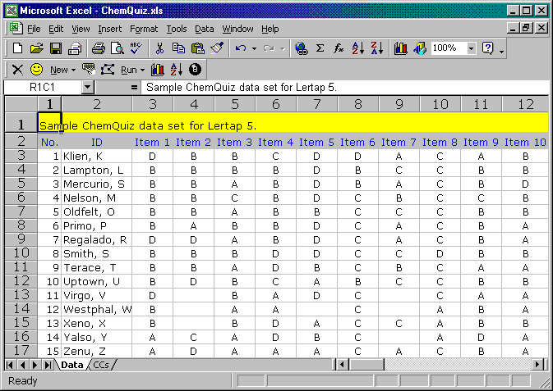

Related Lertap control cards are, of course, in the CCs worksheet, which is shown below. The *col card indicates where the item responses are, while the *key card has the correct answers, one per item:

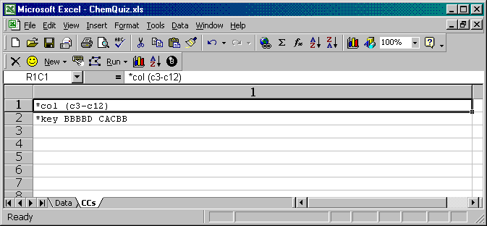

Using Run to Interpret the CCs Lines
Getting results is a two-step process. The first step is to use the Run menu to ask Lertap to interpret the lines in the CCs worksheet, looking for possible errors.

Click on Run:

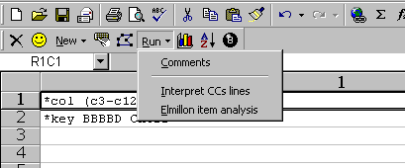

Mouse to the line which says Interpret CCs lines, and click on it. Lertap will read the CCs cards, and is supposed to report any errors which it finds. Note: the prototype of the system, the version under beta testing as this document was created, has recognised weaknesses in this area—it clearly is not picking up many errors, and the diagnostic messages provided for some errors can be misleading. These shortcomings are being addressed; more testing is required.

If no CCs errors are found, Lertap will run through the Data worksheet, and make a summary of item response frequencies. When it finishes this it puts up a screen similar to this one:

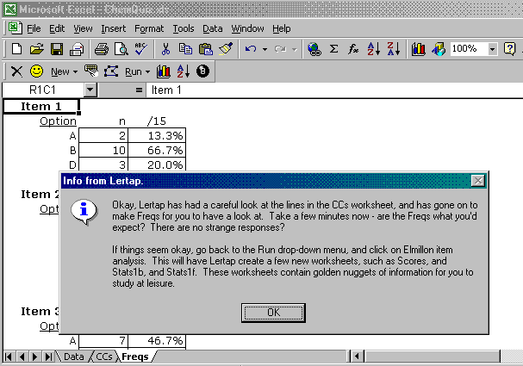

The dialog box is closed by clicking the OK button, and, with the box out of the way, we can see response frequencies, such as the ones displayed below:

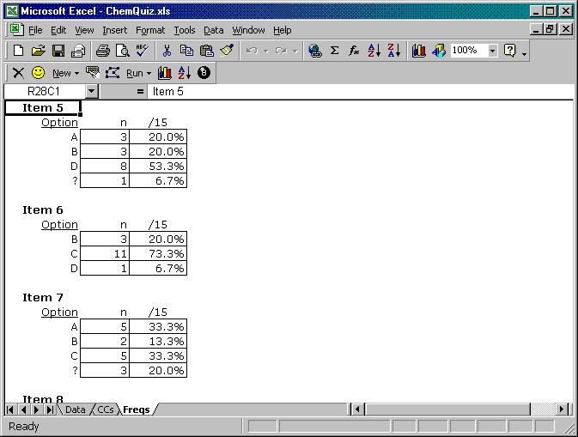

Notice (above) that Lertap has added a worksheet called “Freqs” to the workbook. This is seen at the bottom of the screen, where the worksheet tabs are showing.

There are three tabs, labelled Data CCs and Freqs. However, at this point the workbook has more than three worksheets. Lertap has produced another worksheet called “Sub1”, but it’s hidden from immediate view—below I’ll show you how to unhide it.

Look at the freqs above, would you? I’ve scrolled the worksheet so that we can see results for three of the 10 items.

Notice, first of all, that the results for each item have a header, such as Item 5, Item 6, and Item 7. These headers come from the column headings in row 2 of the Data worksheet. The items can have any heading you wish. Indonesian users, for example, will often label the items as Soal 1, Soal 2, and so on, and these handles would then appear as item headers in the Freqs worksheet. It is possible to run without any column headings in the Data worksheet, in which case Lertap will use the column’s number as a header in the Freqs worksheet.

Next, notice that the freqs listing is very simple. It lists the number of times a particular character was found as an item response. At this point in the data analysis, Lertap allows an item response to be any upper case letter from the Roman alphabet, A through Z, any lower case letter from the same alphabet, a through z, or any of the ten Arabic number symbols, 0 through 9. When Lertap’s Freaker program finds something in a column which is not an upper case letter, a lower case letter, or a digit, it tallies the response in its “other” category. A space is such a character.

Looking at the freqs display above, Item 5 has one “other” response, identified in the listing by the ? mark, while Item 7 has three “other” responses. To find out what these “other” responses were you’d refer back to the Data worksheet. In this case they are spaces—you can see what appear to be empty cells in the Data sheet. (A subtle point is that we cannot in fact tell if those cells are entirely empty, or contain a space. Because spaces don’t have much of a profile, some users will carry a missing data code in their work; instead of entering a space for a non response, as I tend to do, they will, for example, enter a 9.)

The information in the Freqs worksheet is important. Beginning Lertap users tend to ignore the Freqs listing, but they shouldn’t. It’s a quick way to see how many strange responses may have crept into the data processing. If item response codes are supposed to be A B C or D, then we would not want to find lower case letters as responses, nor digits. The Freqs worksheet provides the means to quickly check for what some senior data analysts call “mispunches”, that is, incorrect data.

The Freqs worksheet is not the only worksheet which results from clicking on Interpret the CCs lines. Lertap also creates a crucial system file called “Sub1”. By system file is meant an internal file, a special Excel worksheet which contains critical information about test items, their responses, and how to score them. Ordinarily only very experienced users would bother looking at a Sub worksheet; such sheets contain a lot of information, and much of it is not well formatted. But we should look at one for sure.

The Sub1 Worksheet
Interpreting the CCs lines has Lertap add the Freqs worksheet to your workbook, and a hidden worksheet called “Sub1” as well. “Sub” means subtest. The idea of a subtest is common in this sort of work—it’s nothing but a grouping of items which are to be scored together. When there’s just a single collection of items the term “test” might be more appropriate, but even when this is the case, Lertap will still tend to refer to the collection as a subtest.

Before you can see Sub worksheets you need to Unhide them. Take your little mouse, wander up to Excel’s Format menu, and navigate to the Sheet Unhide option, as shown below:

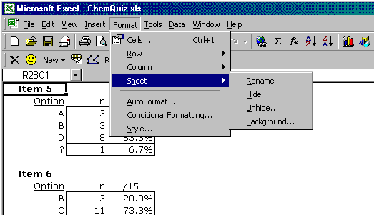

Follow your nose, and Unhide the Sub1 worksheet. Here’s what it might look like:

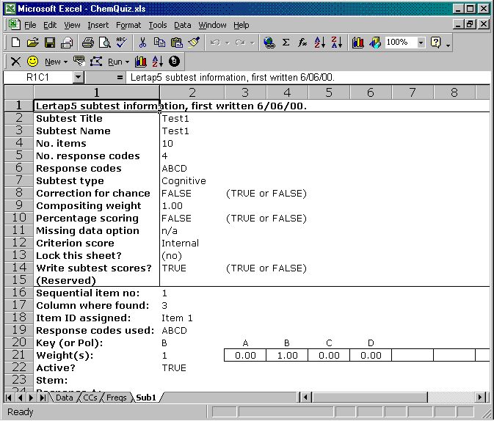

Sub worksheets have two parts. At the top they have information about the subtest itself. A subtest corresponds to a *col card in the CCs worksheet. There will be one Sub worksheet for each *col card, and the Sub sheets will usually be numbered sequentially, such as Sub1, Sub2, Sub3 ….

The subtest data for the ChemQuiz data set is seen above in rows 1 through 15 of the worksheet. It is possible to get in and alter the information in this sheet, but you’ll get into trouble unless you know what you’re doing. (I recommend leaving Sub sheets alone, and this is why they’re usually hidden.)

The subtest data section is followed by information on each of the items which belongs to the subtest. Here again the information may be changed, but I strongly advise against it.

Beginning and everyday users of Lertap 5 should be able to get by without having or even wanting to unhide their Sub worksheets. However, when things go wrong, and you can’t understand why Lertap has behaved as it has, a look at the Sub sheet might save you having to email us at Lertap HQ. The information in Sub sheets is derived directly from the CCs worksheet; it has nothing to do, nothing at all, with what might be in the Data worksheet. If Lertap misbehaves it will most often be due to an error in the CCs lines; sometimes these errors can be detected by looking at Sub worksheets.

Let’s think about moving on. We’ve gone up to the Run menu on the Lertap toolbar, and clicked on the option which says Interpret the CCs lines. If things seem in order, we’d then return to the Run menu, and click on the Elmillon item analysis option.

What if things don’t go well? For example what if the Freqs worksheet points out some bad responses? Excellent question. Do not proceed. Fix the errors, then return to the Run menu, and again click on the Interpret the CCs lines option. If you do this you may find Lertap pipes up with a warning message, saying that it’s going to erase some of your worksheets. It will be referring to any Freqs and Sub worksheets which may be hanging on from the last Run, and it’s generally quite okay to delete them.

Elmillon Item Analysis
The very first version of Lertap was made for the Venezuelan Ministry of Education in 1972. When it was completed, Rogelio Blanco, head of the section in charge of data banking and national assessment, conveyed his gratitude by shaking hands, and saying “un millon”. That’s equivalent to saying “thanks a million” in English speaking countries. Since that day the main item analysis section of the Lertap system has been referred to as Elmillon.

So here we are then, ready to Elmillon, right? Terrific. Go up to the Run menu on Lertap’s toolbar and click on the Elmillon item analysis option.

What happens? Quite a bit. Lertap goes out to have a look at the Sub worksheets resulting from the first step, and uses the information they contain to derive a score, or scores, for each test taker. It writes these into a new worksheet called Scores.

Then it goes back and reads the data again, this time computing item and test statistics. It produces two stats worksheets for each subtest, one, called Stats1f for the first subtest, has a complete, very detailed summary of item and test statistics. The other, called Stats1b, has a much condensed summary of item statistics. We’ll take a look at these in turn.

Note: a click on the Elmillon item analysis option gets Lertap to use information found in the Sub and Data worksheets. At this point the system does not read the CCs lines again; these lines are looked at only when the Interpret CCs lines option is taken.

The Scores Worksheet
Lertap likes to make test scores. There will be one score for each subtest, that is, for each *col card found in the CCs worksheet. The scores will be labelled using the contents of an ID field, if there is one. By ID field is meant a column in the Data sheet which has the letters id, upper or lower case, at the beginning. This column must be either the first or second column in the Data worksheet.

Lertap will look at the first column in the Data sheet to see what it’s got in row 2. If there’s a header there which begins with the letters id, Lertap will use the contents of this column to label the scores. If the header in R2C1 (row 2, column 1) does not begin with the letters id, Lertap jumps one column to the right, and looks at the header in R2C2 (row 2, column 2). If it finds a header there which begins with id, it will use the information in column 2 to label the scores. If it can’t find headers in column 1 or 2 which start with the letters id, Lertap will simply number the scores sequentially.

Whoops, Larry—I have my ID stuff in the third column. What should I do? All is not lost; you can move the third column to the left, so that it becomes the second column.

Here’s the top part of the Scores worksheet for the ChemQuiz data set:

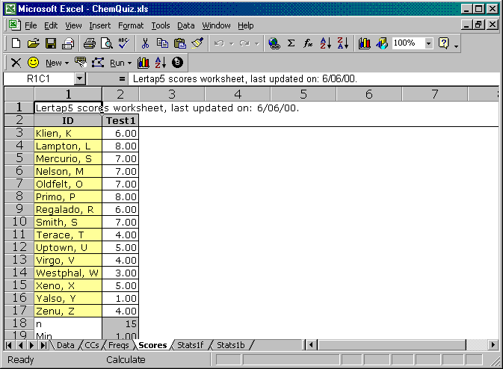

You can see that Lertap has called the scores “Test1”. Is it possible to use some other title for the scores, I don’t like Test1? Most certainly it is; it’s done by adding a *sub card to the CCs lines. If the CCs lines for ChemQuiz had been

*col (c3-c12)
*sub name=(Chemistry quiz given in class 6 June.), title=(Quiz6Jun)
*key BBBBD CACBB

then the scores would have been labelled Quiz6Jun instead of Test1.

We should look at the bottom part of the Scores worksheet too. Here ‘tis:

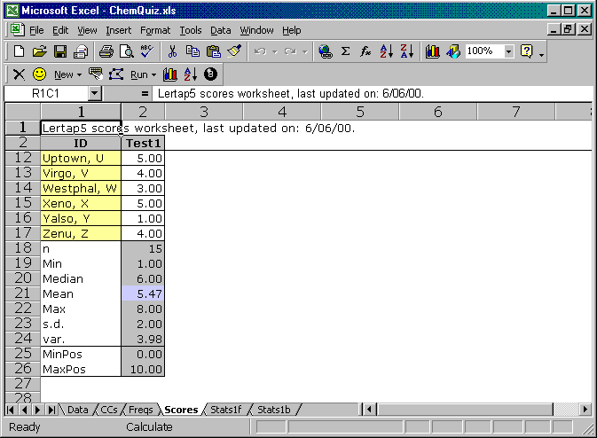

The summary descriptive statistics which show at the bottom of the sheet have two parts. The top part, rows 18 through 24 above, is completed by Excel. If you know how to use standard Excel functions, then you’ll recognise what Lertap does—it simply writes appropriate functions into appropriate cells, and lets Excel do the calcs. For example, if you click on cell R18C2 (row 18, column 2), where the number 15 is showing, Excel’s formula bar will display =COUNT(R3C:R17C).

If you don’t know about Excel functions, worry not. I would estimate that only 10% of readers will know about such functions. In the present case, for your information, the formula says count all the non-empty cells from row 3 of the present column through row 17 of the present column, and display the result.

The last two rows of the summary statistics, rows 25 and 26 above, are determined by Lertap. In this case, Lertap is saying that the minimum possible score for this subtest, this collection of items, is zero, while the maximum possible score is 10.

How did Lertap figure out that the maximum possible score is 10? Well, it assumes that a student will get one point for each correct answer. A perfect score, all ten items correct, would be 10. Is it possible to give, say, half a point for a correct answer, or maybe two points? Yes, not too difficult at all—but this is the subject of another document; the control cards which do such fancy scoring are called *wts and *mws.

Larry, what’s the difference between the Min and Max statistics, and MinPos and MaxPos? Min and Max are the actual minimum and maximum scores within this class of 15 students, while MinPos and MaxPos are the minimum and maximum possible scores. For this class, no student got a perfect score, but no-one totally bombed out, either. Every student got at least one item right.

When a job contains more than one subtest, Lertap asks Excel to figure out the correlations among the subtests, and gets them to display below the MinPos and MaxPos lines in the Scores worksheet. Here is an example:

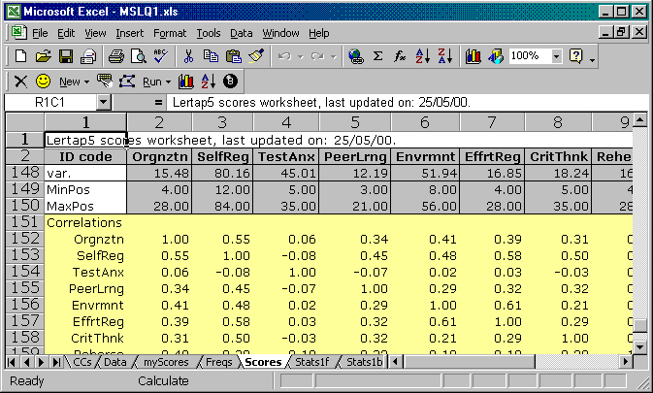

Sorting Test Scores
It is a fairly straightforward process to sort the scores. For example, below I show the result of asking Lertap to ask Excel to sort the ChemQuiz scores in ascending order:

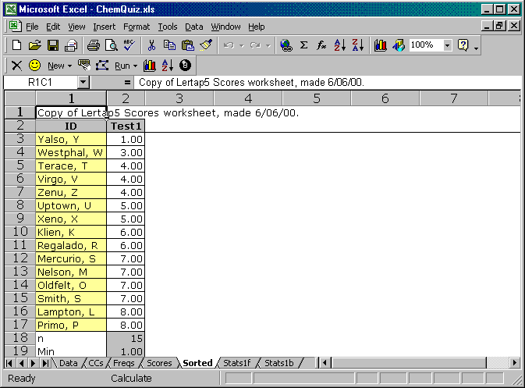

I used the sort icon on Lertap’s toolbar, , to do this. The sort process sees Lertap and Excel team up to make a copy of the Scores worksheet, which they call the Sorted worksheet. This worksheet is then used for the actual sort—in this way the original results are not perturbed.

Can I print the scores? Absolutely. Any of these worksheets can be printed. Excel has a really good Print Preview facility which lets you control the page orientation, portrait or landscape, and even the page margins. Hopefully you will print to a colour printer.

Histograms
Isn’t this cute? I clicked on the histogram icon on Lertap’s toolbar, , to get it:

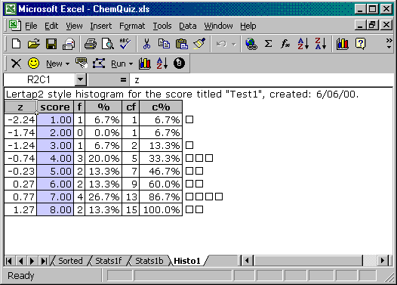

This histogram is cute for sure, a real little darling, but at the same time it’s rather dinky. There are only 15 scores. You need to visit Carlos Gonzalez at la Universidad Central de Venezuela if you want to get into big-time histograms. Here’s one of UCV’s histos for test scores from a mere eleven thousand engineering students:

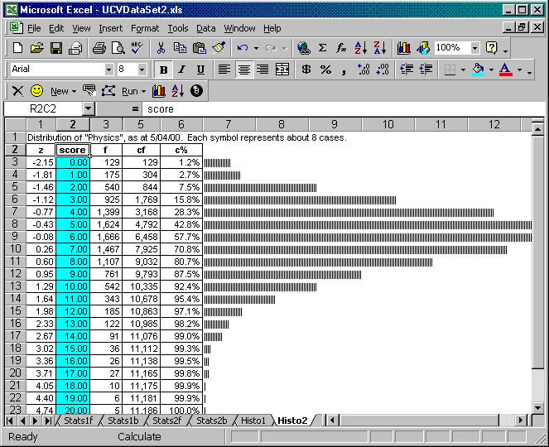

I say, Larry, how many test results may be processed by Lertap? There is no internal Lertap limit—the system will grab memory from your computer until the computer says ouch! To date the largest data set I know of has involved some fifteen thousand students sitting three achievement tests, each with twenty items.

If you want other graphs, such as the box plots which SPSS will produce, the Scores worksheet from Lertap may be formatted for SPSS use by clicking on the eight ball seen on the Lertap toolbar.

The Stats1f Worksheet
Okay, consider us as having scored. Not only did we score, we sorted and histogrammed too. Good fun, but we need to move on. We should look at some item statistics, and so we shall.

Lertap produces two worksheets with item stats. One’s called the “full” worksheet; the other’s known as the “brief” worksheet. The full worksheet for ChemQuiz is called Stats1f. It has two sections, one for item results, and one for subtest results. Here’s an example of what the item results look like:

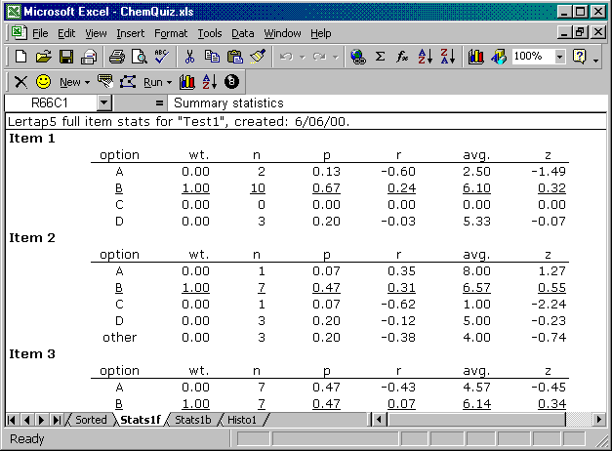

The statistics shown above give complete results for each test item. They show how many students selected each response option (n), the proportion selecting each option (p), the point-biserial correlation between an option and the criterion scores (r), the average criterion score among the students who took each option (avg.), and the z-score corresponding to this average score. The correlation coefficient is corrected for what’s called part-whole inflation; if you’re a former user of an earlier Lertap, Version 2, you should be advised that that version did not correct for this type of inflation—the correction first appeared in Version 3.

The results for the correct answer are underlined. Here (above) we can see that 10 people, 67% answered Item 1 correctly, with their average criterion score being 6.10. The z column shows that the students who selected two of the distracters for Item 1 had below-average criterion scores. It is also obvious that one of the distracters failed to distract; option C did not fool anyone.

What is the criterion score? The default criterion score used by Lertap is the subtest score. Is it possible to use another criterion? Yes.

What does “other” mean? The “other” line appears in the results when students did not respond to an answer, or when a data processing error was made. In the ChemQuiz data set, three students did not answer Item 2 (for example). Note: here the term “other” is more restrictive than it was when we were looking at Freqs—now “other” refers to any response which is not one of the specified response codes for the item. For example, the items in ChemQuiz all use A B C and D as their response codes. A lower-case version of one of these letters would be considered an error, and would be included in the “other” category by Lertap’s Elmillon program.

After the item results, the Stats1f worksheet gets into summary statistics, such as the following:

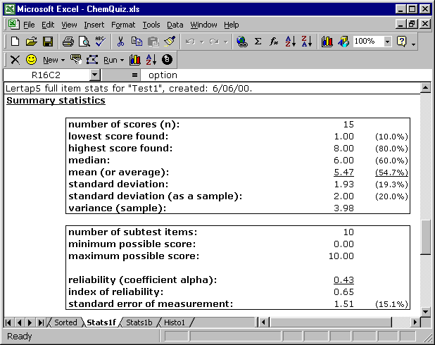

The summary section includes a quick picture of item difficulties and discrimination coefficients, as shown here:

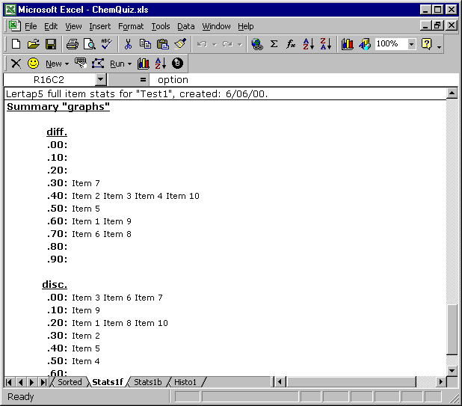

The Stats1b Worksheet
The Stats1f worksheet displays complete item statistics in a format which has been characteristic of Lertap versions throughout time, which is to say three decades. New in Lertap 5 is a much condensed display of item results. Have a look:

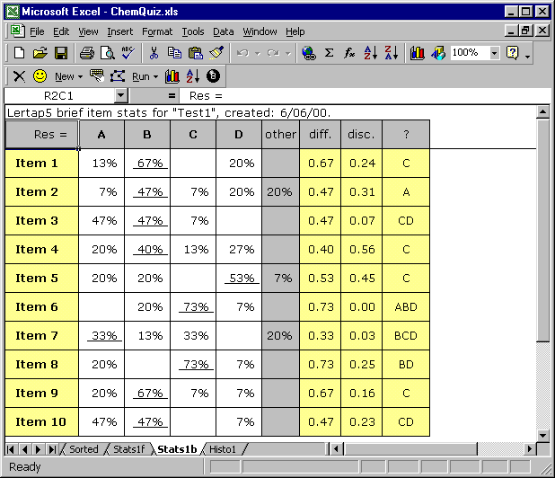

The Stats1b display sets aside just a single line for each item’s results, but each line packs quite a bit of information, especially in the last column, where a profile of distracter performance is provided.

In normal testing situations we want distracters to serve as foils, to draw off those whose knowledge of the material tends to be weak. A distracter’s job is to appear plausible to students whose topic mastery is below average. If an item’s distracters fail in this task they will be flagged in the last column, that headed with the ? mark. Good tests will have few flags in the last column. Really good tests will have none. (Note: to be fair, the test should be taken by quite a few students in order for the distracters to have an adequate chance to do their job—the ChemQuiz test was taken by only a few students, not enough to make very conclusive statements about distracter quality.)

Re-Runs and Such Things
Having seen Elmillon’s results, test users will frequently want to make some changes in their CCs lines, and re-run their analyses. Can do? To be sure. Make the changes, and return to the Run menu, where you will Interpret the CCs lines, and then proceed to Elmillon item analysis.

When this is done, however, Lertap will klack the klaxon. It’ll say Watch out!, I’m going to delete some of your worksheets. The worksheets to be zapped include Freqs, Subs, Scores, Stats, and Histos. There’s usually no harm in deleting these sheets; presumably most or all of them will be regenerated when you go through the re-run. But, if you’d like to keep some or all of these sheets, you can rename them before you begin your re-run.

How do I rename a worksheet? I find right-clicking on the worksheet’s tab to be fastest. Below I show what happened when I took my mouse down to the tab for the Scores worksheet, and clicked on the right-hand (finger?) mouse button:

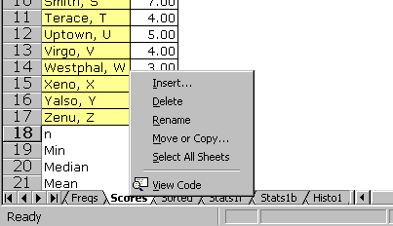

There is another way to rename worksheets—use Excel’s Format menu and let your mouse hover over Sheet.

When you rename a worksheet, try to add something in front of the former name. For example, you might rename Scores as Run1Scores. Don’t use a name which begins with the same characters as the former name; do not, for example, rename Scores as ScoresFromRun1—new names which begin the same as old names do can cause problems for Lertap in certain circumstances.

Did you notice that the pop-up menu shown above allows you to do much more than rename a worksheet? Yes indeed. For example, you can copy a worksheet. If you have a single sheet which you’d like to share with someone, use the Move or Copy option to copy it to a (new book). Then save the (new book) and send it to whomsoever. I have put brackets around new book as that’s how my version of Excel displays it.

Boy Scouts are Always Careful
Don’t get carried away with re-runs and right mouse clicks. Do all possible to avoid deleting your Data and CCs sheets, especially Data. You can protect a worksheet so that it cannot be easily deleted. How? Look:

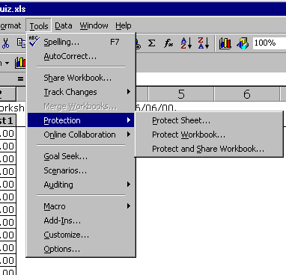

You should protect worksheets against accidental fiddles. Highly recommended for all Lertap Scouts.

Affective Test Results
Users with an affective test to process will see Stats1f and Stats1b worksheets different to those shown above. Here’s a typical Stats1f sheet for the affective case (in this case it’s Stats5f as this screen shot is from a job with multiple subtests):

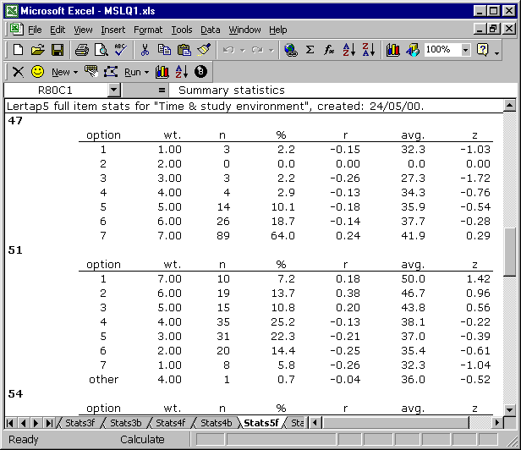

Summary stats for affective tests differ to those for cognitive tests. Have a look:

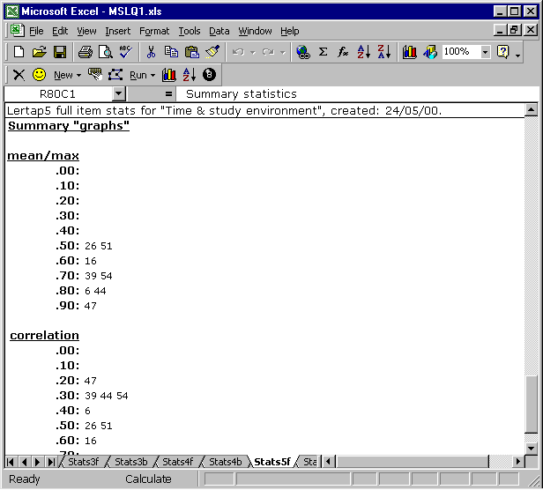

The mean/max summary above is new to this version of Lertap. It quickly indicates which items had means closest to their maximum possible score.

Here are the condensed results corresponding to the full results above:

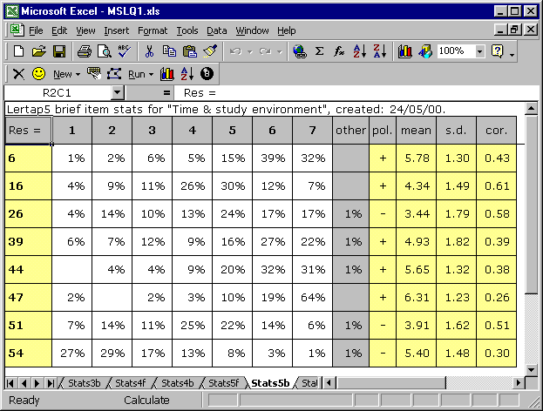

The eight items in this affective scale, or subtest, were scored on a 1 to 7 basis. It’s clear that Item 47 had the highest mean, with 83% of respondents selecting either a 6 or 7; dividing this item’s mean of 6.31 by the maximum possible, 7, gives a mean/max index of .90.

What does the pol. column indicate? Whether or not the scoring of an item is reversed. Sometimes affective items have their “best” response at the “low” end of the scale. For example, if we ask students to respond to this “question”: I am often late for class, and score responses such that a 1 is “Not like me”, and a 7 is “Like me”, then the best response is at the low end, and many users would reverse the scoring of such an item, giving 7 points for an answer of 1.

The full and brief worksheets for affective tests provide unique information, unlike their cognitive test counterparts. For example, the full stats for affective test items do not include the mean, s.d., and cor. information seen in the brief stats. In this sense, the so-called brief results for affective tests are really not so brief.

Charts
In the middle of June, 2000, another icon was added towards the right end of the Lertap toolbar; it shows next to the eight ball in the snapshot below (that is, the second icon from the right end of the toolbar):

A click on this icon will produce charts, such as the following:

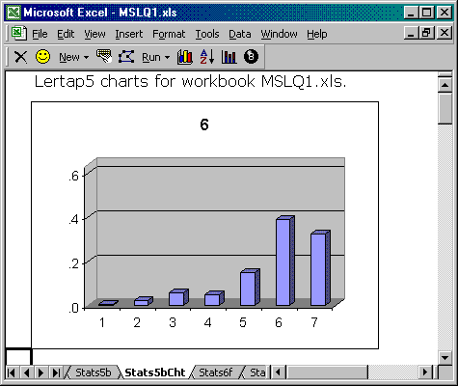

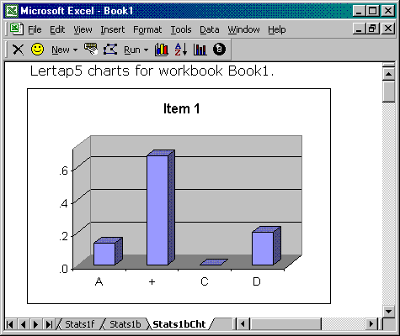

The two sample charts above indicate the general style of these graphs for an affective subtest item, item “6”, having 7 response options, and a cognitive subtest item, “Item 1”, with four response possibilities. When the item is a cognitive one, the keyed-correct response is marked by a + sign.

In order to make charts you must have first produced a worksheet with Lertap5 brief item stats, and you must have such a worksheet on view before you click on the icon. There are appropriate messages built in to advise you of these requirements, should you forget them.

Before the charts are made, the program scans all the figures in the brief stats page to determine the maximum percentage value on the page. It then uses this information to scale the vertical axis of the graph—the result is a set of graphs to the same scale for all items. Note that the vertical scale, or y-axis, shows proportions instead of percentages. This was done to save a bit of plotting space.

Beer with Me
And that, not so briefly, will have to close out your introduction to using Lertap’s Run menu. Hope you have borne up better than I have.

Larry, if we send a business-class air ticket, will a friendly, multi-lingual Lertap trainer come to our place to give us a more extensive Run around? Only if there’s beer and peanuts, and it’s summer there.

Write with your problems. Not all your problems, just the Lertap ones. A working email address is l.nelson@curtin.edu.au (if this address appears different to others you’ve seen, it’s because L Nelson has several aliases).

